**Personas and User Stories**

**Boutique Recruitment**

**JC Consulting**

|  |  |
| --- | --- |
| Industry Partner | JC Consulting |
| Primary Instructor | Anjana Shah |
| Team Member | Abdallahman Habyarimana – 101087205 |
| Team Member | Anushka Aggarwal – 101195651 |
| Team Member | Karanjot Singh- 101195883 |
| Team Member | Renata Moura - 101096098 |
| Team Member |  |

Document Revision History

|  |  |
| --- | --- |
| Revision # | Date |
| Revison 1 | 10/11/2018 |

|  |  |
| --- | --- |
| **Project:** | Boutique Recruitment |
| **Prepared By:** | Abdallahman Habyarimana |
| **Document Version:** | Version 1.0 |
| **Published Date:** | 11 October 2018 |

| **Name** | **Title** |
| --- | --- |
| Tyler Krimmel | *Sponsor* |
| Renata Moura | *Project Leader* |
| Anushka Aggarwal | *Team member* |
| Karanjot Singh | *Team member* |
| Abdallahman Habyarimana | *Team member* |

Contents

1 Persona 4

1.1 Client X 4

1.2 Allocator Department 5

1.3 Evaluation Department 6

2 User Stories 7

2.1 Client X 7

2.2 Evaluation Department 7

2.3 Allocation Department 7

3 Approval 7

Personas and User Stories

# Persona

## Client X

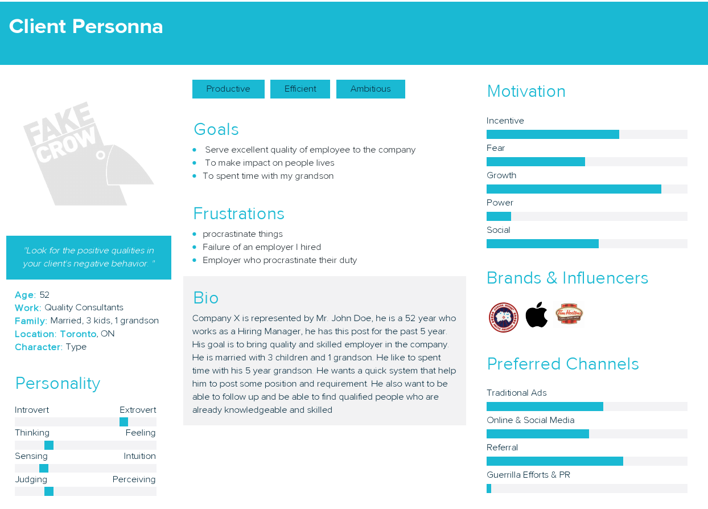

## Allocator Department

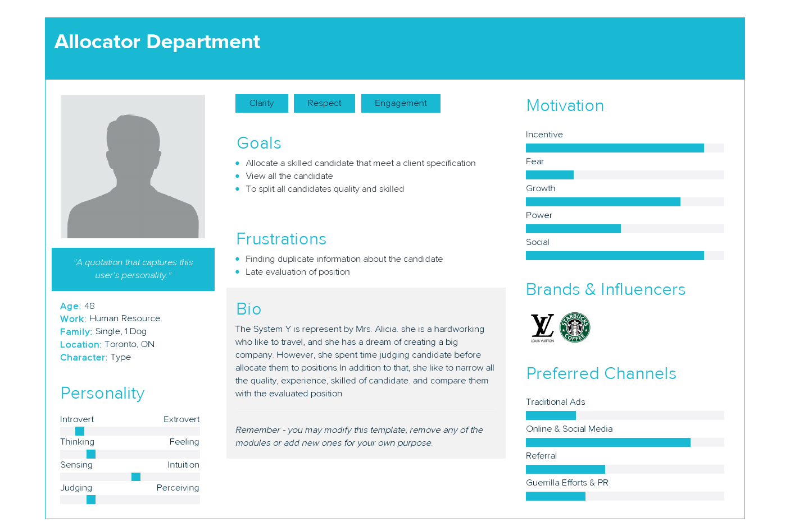

## Evaluation Department

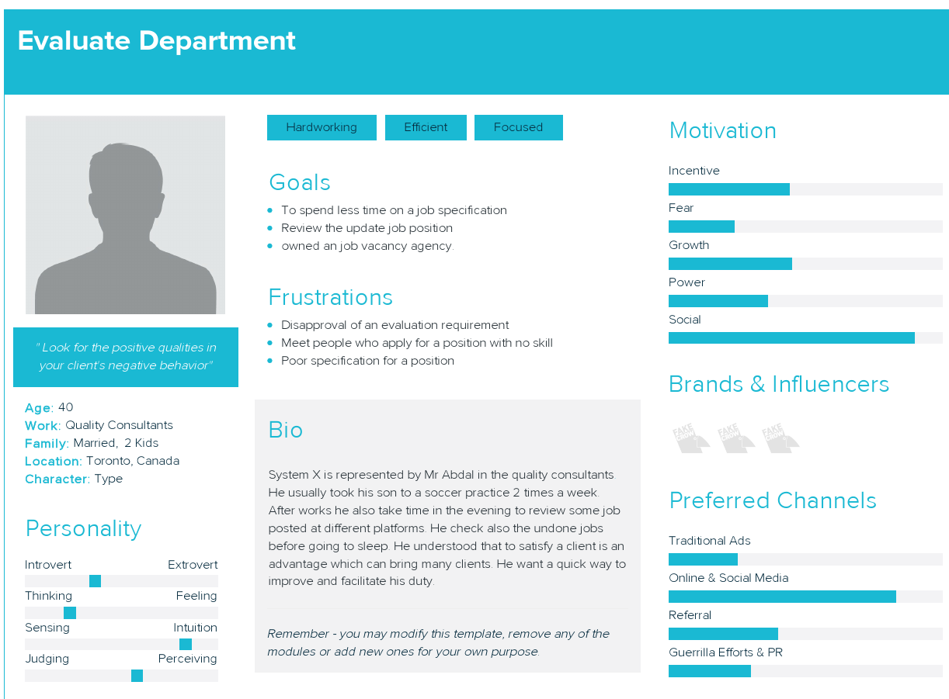

# User Stories

## Client X

As a client, I want an easy way to access system because I don’t have a lot of time to be filling out applications due to my rigorous.

As a client, I want to post different position to the system so that I can hire skilled and qualified candidate to work for my organization.

## Evaluation Department

As an evaluator, I want to be able to access the system so that I can be able to evaluate position posted by clients.

## Allocation Department

As an allocator I want to easily retrieve evaluated position and allocate them to candidate

# Approval

The signatures below indicate their approval of the contents of this document.

|  |  |  |  |
| --- | --- | --- | --- |
| Project Role | Name | Signature | Date |
|  |  |  |  |
|  |  |  |  |
|  |  |  |  |
|  |  |  |  |
|  |  |  |  |
|  |  |  |  |